- What I is the structure exactly showing? The actual candle? How to interprete the actual result on the screen? (see screenshot bellow green box 1)
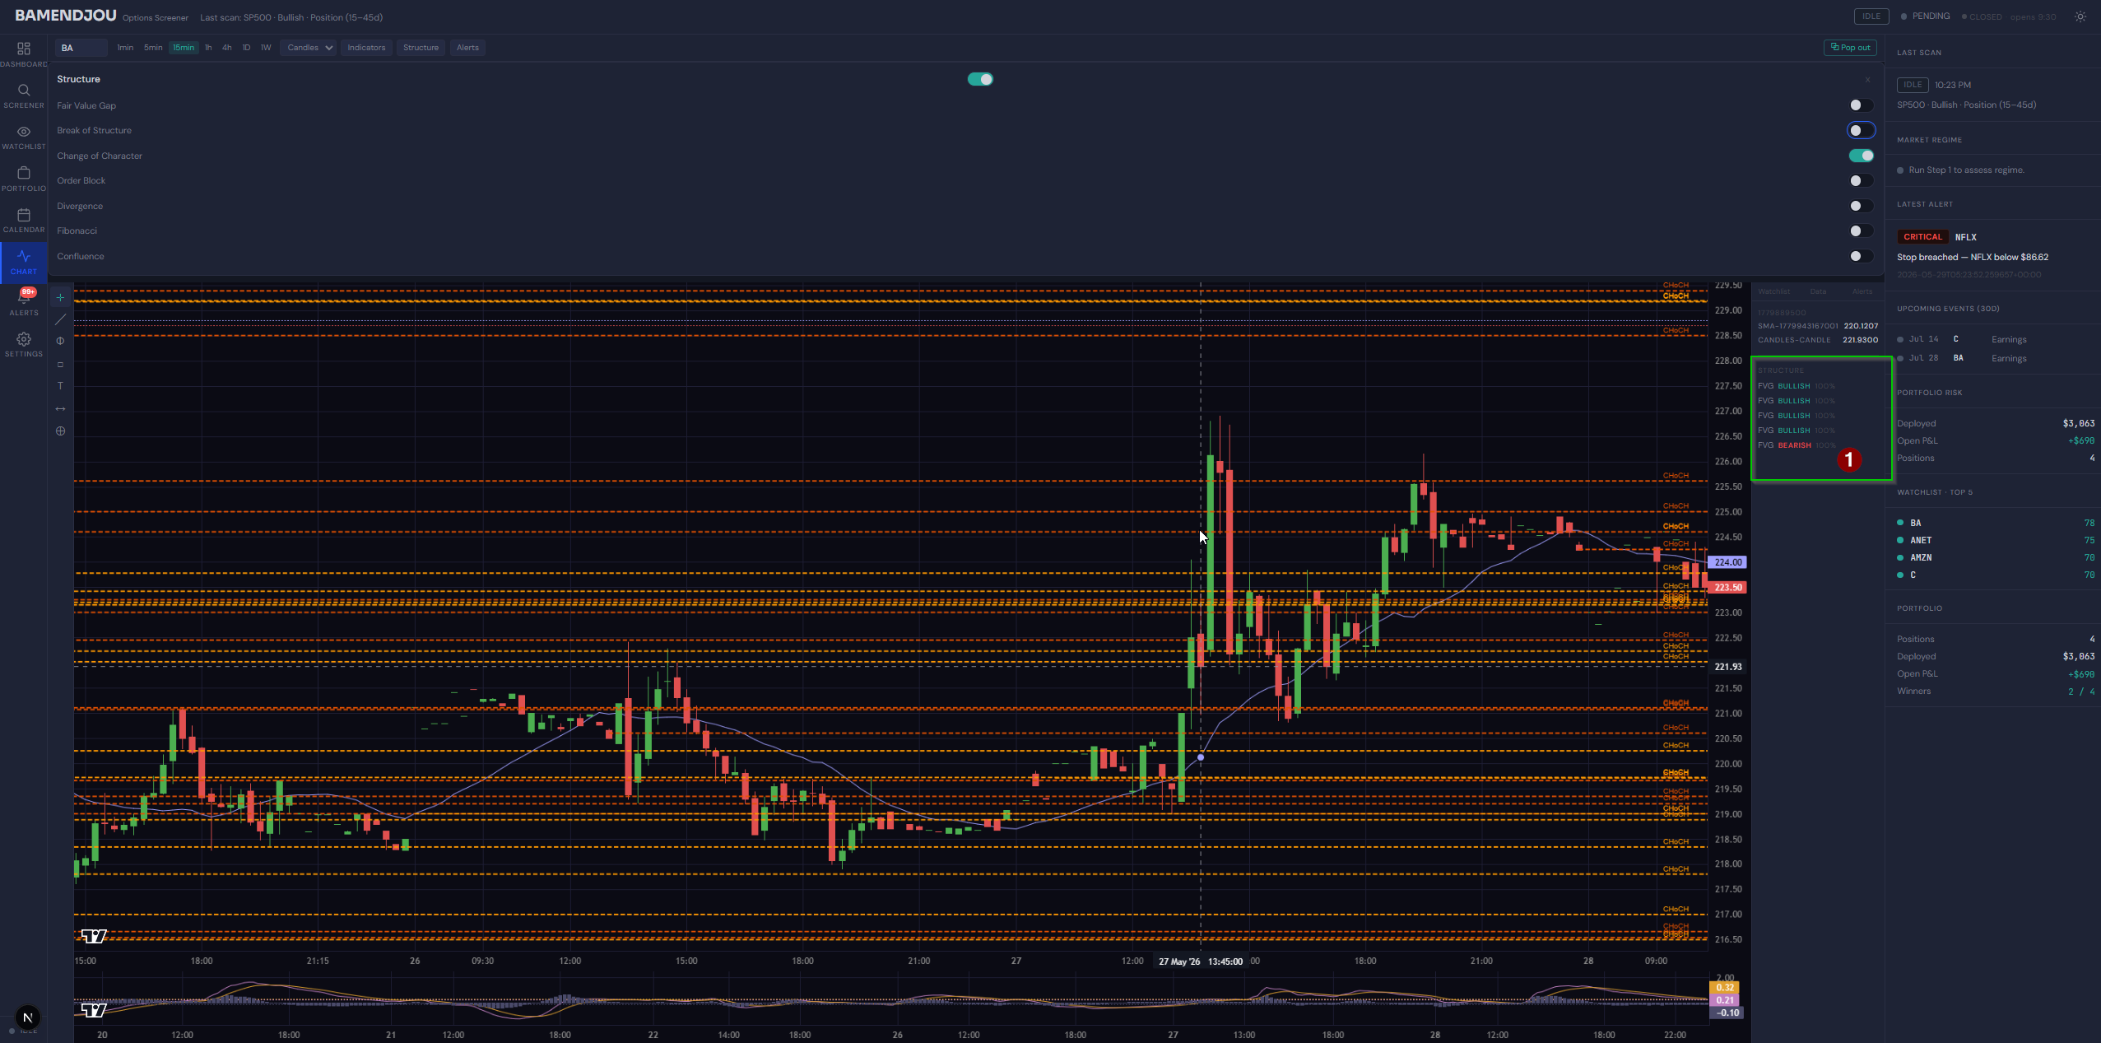
- The Buton Structute should apper Over the Graph when selected similar to indicators.. Not Pusching the Graph Down
- Reduce the size of the Structure card. Right now its difficlut to match the buttons on the right to the text on the left (see screenshot bellow green box 1)
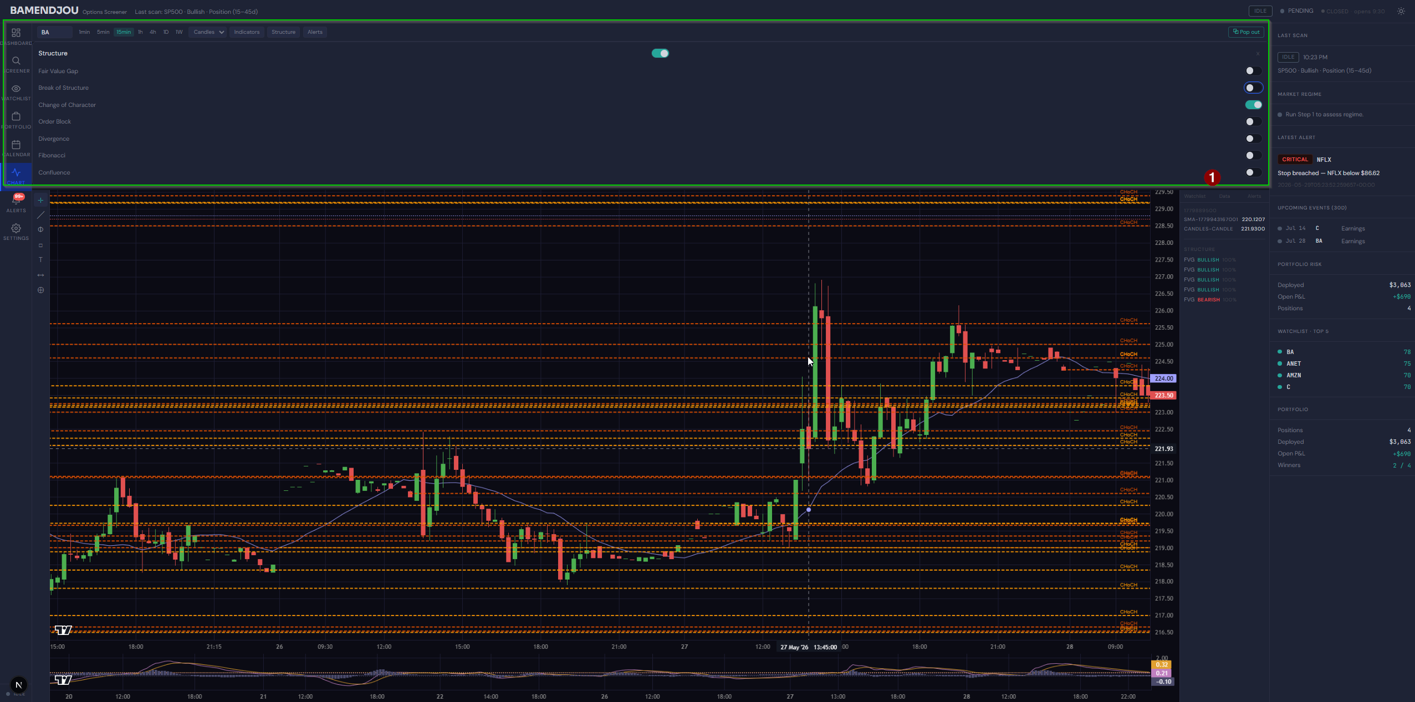

Got this error after selecting AMZN on the grapgh (see screenshot bellow)
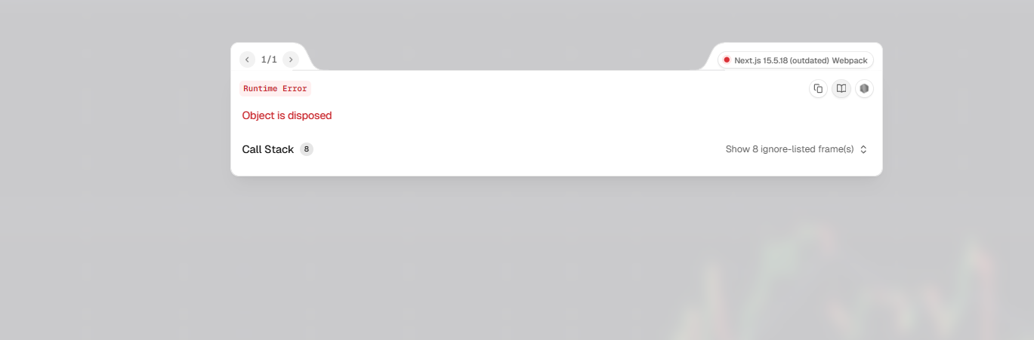
Beloow is th log of the backend when the error happened
Running database migrations...
INFO [alembic.runtime.migration] Context impl SQLiteImpl.
INFO [alembic.runtime.migration] Will assume non-transactional DDL.
INFO: Started server process [17384]
INFO: Waiting for application startup.
2026-05-29 07:22:16,130 INFO sqlalchemy.engine.Engine BEGIN (implicit)
2026-05-29 07:22:16,130 INFO sqlalchemy.engine.Engine SELECT scan_sessions.id, scan_sessions.status, scan_sessions.last_result_json, scan_sessions.last_request_json, scan_sessions.created_at, scan_sessions.updated_at
FROM scan_sessions
WHERE scan_sessions.id = ?
2026-05-29 07:22:16,130 INFO sqlalchemy.engine.Engine [generated in 0.00054s] ('current',)
2026-05-29 07:22:16,146 INFO sqlalchemy.engine.Engine ROLLBACK
INFO: Application startup complete.
INFO: Uvicorn running on http://127.0.0.1:8000 (Press CTRL+C to quit)
INFO: 127.0.0.1:51776 - "WebSocket /chart/stream/CLX?interval=4h" [accepted]
INFO: connection open
$CLX: possibly delisted; no price data found (1h 2024-05-29 -> 2026-05-29) (Yahoo error = "1h data not available for startTime=1716955200 and endTime=1780027200. The requested range must be within the last 730 days.")

1 Failed download:
['CLX']: possibly delisted; no price data found (1h 2024-05-29 -> 2026-05-29) (Yahoo error = "1h data not available for startTime=1716955200 and endTime=1780027200. The requested range must be within the last 730 days.")
yfinance returned 0 bars for CLX [interval=4h]
No intraday data from any source for CLX
2026-05-29 07:23:38,994 INFO sqlalchemy.engine.Engine BEGIN (implicit)
2026-05-29 07:23:39,026 INFO sqlalchemy.engine.Engine SELECT portfolio_positions.id, portfolio_positions.rec_id, portfolio_positions.symbol, portfolio_positions.contract, portfolio_positions.direction, portfolio_positions.entry_price, portfolio_positions.qty, portfolio_positions.entry_date, portfolio_positions.stop, portfolio_positions.targets, portfolio_positions.dte_total, portfolio_positions.created_at
FROM portfolio_positions ORDER BY portfolio_positions.created_at
2026-05-29 07:23:39,026 INFO sqlalchemy.engine.Engine [generated in 0.00048s] ()
INFO: 127.0.0.1:64172 - "GET /api/regime HTTP/1.1" 200 OK
2026-05-29 07:23:51,336 INFO sqlalchemy.engine.Engine BEGIN (implicit)
2026-05-29 07:23:51,349 INFO sqlalchemy.engine.Engine SELECT watchlist_symbols.id, watchlist_symbols.symbol, watchlist_symbols.created_at
FROM watchlist_symbols ORDER BY watchlist_symbols.created_at
2026-05-29 07:23:51,351 INFO sqlalchemy.engine.Engine [generated in 0.00079s] ()
INFO: 127.0.0.1:59528 - "WebSocket /chart/stream/BA?interval=15min" [accepted]
INFO: connection open
2026-05-29 07:23:51,389 INFO sqlalchemy.engine.Engine BEGIN (implicit)
2026-05-29 07:23:51,389 INFO sqlalchemy.engine.Engine SELECT portfolio_positions.id, portfolio_positions.rec_id, portfolio_positions.symbol, portfolio_positions.contract, portfolio_positions.direction, portfolio_positions.entry_price, portfolio_positions.qty, portfolio_positions.entry_date, portfolio_positions.stop, portfolio_positions.targets, portfolio_positions.dte_total, portfolio_positions.created_at
FROM portfolio_positions
2026-05-29 07:23:51,389 INFO sqlalchemy.engine.Engine [generated in 0.00041s] ()
2026-05-29 07:23:51,389 INFO sqlalchemy.engine.Engine BEGIN (implicit)
2026-05-29 07:23:51,389 INFO sqlalchemy.engine.Engine SELECT watchlist_symbols.symbol
FROM watchlist_symbols
2026-05-29 07:23:51,389 INFO sqlalchemy.engine.Engine [generated in 0.00031s] ()
2026-05-29 07:23:51,393 INFO sqlalchemy.engine.Engine SELECT scan_sessions.id, scan_sessions.status, scan_sessions.last_result_json, scan_sessions.last_request_json, scan_sessions.created_at, scan_sessions.updated_at
FROM scan_sessions
WHERE scan_sessions.id = ?
2026-05-29 07:23:51,393 INFO sqlalchemy.engine.Engine [cached since 95.26s ago] ('current',)
2026-05-29 07:23:51,393 INFO sqlalchemy.engine.Engine BEGIN (implicit)
2026-05-29 07:23:51,397 INFO sqlalchemy.engine.Engine SELECT alert_rules.id, alert_rules.user_id, alert_rules.name, alert_rules.symbol, alert_rules.interval, alert_rules.enabled, alert_rules.rule_json, alert_rules.cooldown_minutes, alert_rules.expiry_date, alert_rules.created_at, alert_rules.last_triggered_at
FROM alert_rules
WHERE alert_rules.user_id = ? ORDER BY alert_rules.created_at DESC
2026-05-29 07:23:51,397 INFO sqlalchemy.engine.Engine [generated in 0.00023s] ('default',)
2026-05-29 07:23:52,245 INFO sqlalchemy.engine.Engine SELECT portfolio_positions.id, portfolio_positions.rec_id, portfolio_positions.symbol, portfolio_positions.contract, portfolio_positions.direction, portfolio_positions.entry_price, portfolio_positions.qty, portfolio_positions.entry_date, portfolio_positions.stop, portfolio_positions.targets, portfolio_positions.dte_total, portfolio_positions.created_at
FROM portfolio_positions ORDER BY portfolio_positions.created_at
2026-05-29 07:23:52,245 INFO sqlalchemy.engine.Engine [cached since 13.21s ago] ()
INFO: 127.0.0.1:55395 - "GET /api/watchlist HTTP/1.1" 200 OK
2026-05-29 07:23:52,251 INFO sqlalchemy.engine.Engine ROLLBACK
INFO: 127.0.0.1:64172 - "GET /alerts/rules HTTP/1.1" 200 OK
2026-05-29 07:23:52,251 INFO sqlalchemy.engine.Engine ROLLBACK
INFO: 127.0.0.1:53660 - "GET /api/alerts HTTP/1.1" 200 OK
2026-05-29 07:23:52,261 INFO sqlalchemy.engine.Engine ROLLBACK
2026-05-29 07:23:52,261 INFO sqlalchemy.engine.Engine BEGIN (implicit)
2026-05-29 07:23:52,261 INFO sqlalchemy.engine.Engine SELECT watchlist_symbols.id, watchlist_symbols.symbol, watchlist_symbols.created_at
FROM watchlist_symbols ORDER BY watchlist_symbols.created_at
2026-05-29 07:23:52,261 INFO sqlalchemy.engine.Engine [cached since 0.9128s ago] ()
2026-05-29 07:23:52,261 INFO sqlalchemy.engine.Engine BEGIN (implicit)
2026-05-29 07:23:52,261 INFO sqlalchemy.engine.Engine SELECT alert_rules.id, alert_rules.user_id, alert_rules.name, alert_rules.symbol, alert_rules.interval, alert_rules.enabled, alert_rules.rule_json, alert_rules.cooldown_minutes, alert_rules.expiry_date, alert_rules.created_at, alert_rules.last_triggered_at
FROM alert_rules
WHERE alert_rules.user_id = ? ORDER BY alert_rules.created_at DESC
2026-05-29 07:23:52,261 INFO sqlalchemy.engine.Engine [cached since 0.8663s ago] ('default',)
INFO: 127.0.0.1:64172 - "GET /alerts/rules HTTP/1.1" 200 OK
2026-05-29 07:23:52,261 INFO sqlalchemy.engine.Engine ROLLBACK
2026-05-29 07:23:52,266 INFO sqlalchemy.engine.Engine SELECT scan_sessions.id, scan_sessions.status, scan_sessions.last_result_json, scan_sessions.last_request_json, scan_sessions.created_at, scan_sessions.updated_at
FROM scan_sessions
WHERE scan_sessions.id = ?
2026-05-29 07:23:52,266 INFO sqlalchemy.engine.Engine [cached since 96.13s ago] ('current',)
INFO: 127.0.0.1:55395 - "GET /api/watchlist HTTP/1.1" 200 OK
2026-05-29 07:23:52,271 INFO sqlalchemy.engine.Engine ROLLBACK
2026-05-29 07:23:52,272 INFO sqlalchemy.engine.Engine BEGIN (implicit)
2026-05-29 07:23:52,273 INFO sqlalchemy.engine.Engine SELECT watchlist_symbols.id, watchlist_symbols.symbol, watchlist_symbols.created_at
FROM watchlist_symbols ORDER BY watchlist_symbols.created_at
2026-05-29 07:23:52,273 INFO sqlalchemy.engine.Engine [cached since 0.9227s ago] ()
2026-05-29 07:23:52,274 INFO sqlalchemy.engine.Engine SELECT scan_sessions.id, scan_sessions.status, scan_sessions.last_result_json, scan_sessions.last_request_json, scan_sessions.created_at, scan_sessions.updated_at
FROM scan_sessions
WHERE scan_sessions.id = ?
2026-05-29 07:23:52,274 INFO sqlalchemy.engine.Engine [cached since 96.14s ago] ('current',)
INFO: 127.0.0.1:64172 - "GET /api/watchlist HTTP/1.1" 200 OK
2026-05-29 07:23:52,277 INFO sqlalchemy.engine.Engine ROLLBACK
INFO: 127.0.0.1:62958 - "GET /api/news?symbols=SPY,QQQ,VIX,DIA HTTP/1.1" 200 OK
INFO: 127.0.0.1:51372 - "GET /api/events HTTP/1.1" 200 OK
2026-05-29 07:23:53,284 INFO sqlalchemy.engine.Engine ROLLBACK
INFO: 127.0.0.1:63269 - "GET /api/portfolio HTTP/1.1" 200 OK
2026-05-29 07:23:54,554 INFO sqlalchemy.engine.Engine ROLLBACK
2026-05-29 07:23:54,563 INFO sqlalchemy.engine.Engine BEGIN (implicit)
2026-05-29 07:23:54,563 INFO sqlalchemy.engine.Engine SELECT portfolio_positions.id, portfolio_positions.rec_id, portfolio_positions.symbol, portfolio_positions.contract, portfolio_positions.direction, portfolio_positions.entry_price, portfolio_positions.qty, portfolio_positions.entry_date, portfolio_positions.stop, portfolio_positions.targets, portfolio_positions.dte_total, portfolio_positions.created_at
FROM portfolio_positions ORDER BY portfolio_positions.created_at
2026-05-29 07:23:54,563 INFO sqlalchemy.engine.Engine [cached since 15.52s ago] ()
INFO: 127.0.0.1:51372 - "GET /api/portfolio HTTP/1.1" 200 OK
2026-05-29 07:23:56,959 INFO sqlalchemy.engine.Engine ROLLBACK
2026-05-29 07:23:56,960 INFO sqlalchemy.engine.Engine BEGIN (implicit)
2026-05-29 07:23:56,961 INFO sqlalchemy.engine.Engine SELECT portfolio_positions.id, portfolio_positions.rec_id, portfolio_positions.symbol, portfolio_positions.contract, portfolio_positions.direction, portfolio_positions.entry_price, portfolio_positions.qty, portfolio_positions.entry_date, portfolio_positions.stop, portfolio_positions.targets, portfolio_positions.dte_total, portfolio_positions.created_at
FROM portfolio_positions ORDER BY portfolio_positions.created_at
2026-05-29 07:23:56,961 INFO sqlalchemy.engine.Engine [cached since 17.92s ago] ()
INFO: 127.0.0.1:63269 - "GET /api/portfolio HTTP/1.1" 200 OK
2026-05-29 07:24:00,192 INFO sqlalchemy.engine.Engine ROLLBACK
INFO: 127.0.0.1:64536 - "WebSocket /chart/stream/BA?interval=1min" [accepted]
INFO: connection open
Tradier intraday fetch failed for BA: Client error '400 ' for url 'https://api.tradier.com/v1/markets/timesales?symbol=BA&interval=1min&start=2026-04-04&end=2026-05-29&session_filter=all'
For more information check: https://developer.mozilla.org/en-US/docs/Web/HTTP/Status/400
INFO: 127.0.0.1:65320 - "WebSocket /chart/stream/BA?interval=5min" [accepted]
INFO: connection open
INFO: 127.0.0.1:56799 - "WebSocket /chart/stream/BA?interval=15min" [accepted]
INFO: connection open
INFO: 127.0.0.1:55390 - "WebSocket /chart/stream/BA?interval=1h" [accepted]
INFO: connection open
$BA: possibly delisted; no price data found (1h 2024-05-29 -> 2026-05-29) (Yahoo error = "1h data not available for startTime=1716955200 and endTime=1780027200. The requested range must be within the last 730 days.")

1 Failed download:
['BA']: possibly delisted; no price data found (1h 2024-05-29 -> 2026-05-29) (Yahoo error = "1h data not available for startTime=1716955200 and endTime=1780027200. The requested range must be within the last 730 days.")
yfinance returned 0 bars for BA [interval=1h]
No intraday data from any source for BA
INFO: 127.0.0.1:57150 - "WebSocket /chart/stream/BA?interval=4h" [accepted]
INFO: connection open
$BA: possibly delisted; no price data found (1h 2024-05-29 -> 2026-05-29) (Yahoo error = "1h data not available for startTime=1716955200 and endTime=1780027200. The requested range must be within the last 730 days.")

1 Failed download:
['BA']: possibly delisted; no price data found (1h 2024-05-29 -> 2026-05-29) (Yahoo error = "1h data not available for startTime=1716955200 and endTime=1780027200. The requested range must be within the last 730 days.")
yfinance returned 0 bars for BA [interval=4h]
No intraday data from any source for BA
INFO: 127.0.0.1:64757 - "WebSocket /chart/stream/BA?interval=daily" [accepted]
INFO: connection open
$BA: possibly delisted; no price data found (daily 2026-04-04 -> 2026-05-29) (Yahoo error = "Invalid input - interval=daily is not supported. Valid intervals: [1m, 2m, 5m, 15m, 30m, 60m, 90m, 1h, 4h, 1d, 5d, 1wk, 1mo, 3mo]")

1 Failed download:
['BA']: possibly delisted; no price data found (daily 2026-04-04 -> 2026-05-29) (Yahoo error = "Invalid input - interval=daily is not supported. Valid intervals: [1m, 2m, 5m, 15m, 30m, 60m, 90m, 1h, 4h, 1d, 5d, 1wk, 1mo, 3mo]")
yfinance returned 0 bars for BA [interval=daily]
No intraday data from any source for BA
INFO: 127.0.0.1:57253 - "WebSocket /chart/stream/BA?interval=weekly" [accepted]
INFO: connection open
$BA: possibly delisted; no price data found (weekly 2026-04-04 -> 2026-05-29) (Yahoo error = "Invalid input - interval=weekly is not supported. Valid intervals: [1m, 2m, 5m, 15m, 30m, 60m, 90m, 1h, 4h, 1d, 5d, 1wk, 1mo, 3mo]")

1 Failed download:
['BA']: possibly delisted; no price data found (weekly 2026-04-04 -> 2026-05-29) (Yahoo error = "Invalid input - interval=weekly is not supported. Valid intervals: [1m, 2m, 5m, 15m, 30m, 60m, 90m, 1h, 4h, 1d, 5d, 1wk, 1mo, 3mo]")
yfinance returned 0 bars for BA [interval=weekly]
No intraday data from any source for BA
INFO: 127.0.0.1:49307 - "WebSocket /chart/stream/BA?interval=15min" [accepted]
INFO: connection open
INFO: 127.0.0.1:56949 - "WebSocket /chart/stream/BA?interval=1h" [accepted]
INFO: connection open
$BA: possibly delisted; no price data found (1h 2024-05-29 -> 2026-05-29) (Yahoo error = "1h data not available for startTime=1716955200 and endTime=1780027200. The requested range must be within the last 730 days.")

1 Failed download:
['BA']: possibly delisted; no price data found (1h 2024-05-29 -> 2026-05-29) (Yahoo error = "1h data not available for startTime=1716955200 and endTime=1780027200. The requested range must be within the last 730 days.")
yfinance returned 0 bars for BA [interval=1h]
No intraday data from any source for BA
INFO: 127.0.0.1:51978 - "WebSocket /chart/stream/BA?interval=4h" [accepted]
INFO: connection open
INFO: 127.0.0.1:58944 - "WebSocket /chart/stream/BA?interval=15min" [accepted]
INFO: connection open
INFO: 127.0.0.1:63008 - "WebSocket /chart/stream/CLX?interval=15min" [accepted]
INFO: connection open
INFO: 127.0.0.1:63694 - "WebSocket /chart/stream/CLX?interval=1min" [accepted]
INFO: connection open
Tradier intraday fetch failed for CLX: Client error '400 ' for url 'https://api.tradier.com/v1/markets/timesales?symbol=CLX&interval=1min&start=2026-04-04&end=2026-05-29&session_filter=all'
For more information check: https://developer.mozilla.org/en-US/docs/Web/HTTP/Status/400
INFO: 127.0.0.1:57288 - "WebSocket /chart/stream/CLX?interval=5min" [accepted]
INFO: connection open
INFO: 127.0.0.1:60168 - "WebSocket /chart/stream/CLX?interval=15min" [accepted]
INFO: connection open
INFO: 127.0.0.1:56265 - "WebSocket /chart/stream/CLX?interval=1h" [accepted]
INFO: connection open
$CLX: possibly delisted; no price data found (1h 2024-05-29 -> 2026-05-29) (Yahoo error = "1h data not available for startTime=1716955200 and endTime=1780027200. The requested range must be within the last 730 days.")

1 Failed download:
['CLX']: possibly delisted; no price data found (1h 2024-05-29 -> 2026-05-29) (Yahoo error = "1h data not available for startTime=1716955200 and endTime=1780027200. The requested range must be within the last 730 days.")
yfinance returned 0 bars for CLX [interval=1h]
No intraday data from any source for CLX
INFO: 127.0.0.1:64817 - "WebSocket /chart/stream/BA?interval=1h" [accepted]
INFO: connection open
INFO: 127.0.0.1:54094 - "WebSocket /chart/stream/ANET?interval=1h" [accepted]
INFO: connection open
$ANET: possibly delisted; no price data found (1h 2024-05-29 -> 2026-05-29) (Yahoo error = "1h data not available for startTime=1716955200 and endTime=1780027200. The requested range must be within the last 730 days.")

1 Failed download:
['ANET']: possibly delisted; no price data found (1h 2024-05-29 -> 2026-05-29) (Yahoo error = "1h data not available for startTime=1716955200 and endTime=1780027200. The requested range must be within the last 730 days.")
yfinance returned 0 bars for ANET [interval=1h]
No intraday data from any source for ANET
INFO: 127.0.0.1:49526 - "WebSocket /chart/stream/ANET?interval=5min" [accepted]
INFO: connection open
INFO: 127.0.0.1:49915 - "WebSocket /chart/stream/BA?interval=5min" [accepted]
INFO: connection open
INFO: 127.0.0.1:63285 - "WebSocket /chart/stream/BA?interval=15min" [accepted]
INFO: connection open
INFO: 127.0.0.1:61461 - "WebSocket /chart/stream/BA?interval=5min" [accepted]
INFO: connection open
INFO: 127.0.0.1:54813 - "WebSocket /chart/stream/BA?interval=1min" [accepted]
INFO: connection open
INFO: 127.0.0.1:53318 - "WebSocket /chart/stream/BA?interval=5min" [accepted]
INFO: connection open
INFO: 127.0.0.1:58414 - "WebSocket /chart/stream/BA?interval=15min" [accepted]
INFO: connection open
INFO: 127.0.0.1:58321 - "WebSocket /chart/stream/BA?interval=1h" [accepted]
INFO: connection open
$BA: possibly delisted; no price data found (1h 2024-05-29 -> 2026-05-29) (Yahoo error = "1h data not available for startTime=1716955200 and endTime=1780027200. The requested range must be within the last 730 days.")

1 Failed download:
['BA']: possibly delisted; no price data found (1h 2024-05-29 -> 2026-05-29) (Yahoo error = "1h data not available for startTime=1716955200 and endTime=1780027200. The requested range must be within the last 730 days.")
yfinance returned 0 bars for BA [interval=1h]
No intraday data from any source for BA
INFO: 127.0.0.1:62306 - "WebSocket /chart/stream/BA?interval=4h" [accepted]
INFO: connection open
$BA: possibly delisted; no price data found (1h 2024-05-29 -> 2026-05-29) (Yahoo error = "1h data not available for startTime=1716955200 and endTime=1780027200. The requested range must be within the last 730 days.")

1 Failed download:
['BA']: possibly delisted; no price data found (1h 2024-05-29 -> 2026-05-29) (Yahoo error = "1h data not available for startTime=1716955200 and endTime=1780027200. The requested range must be within the last 730 days.")
yfinance returned 0 bars for BA [interval=4h]
No intraday data from any source for BA
INFO: 127.0.0.1:51322 - "WebSocket /chart/stream/BA?interval=daily" [accepted]
INFO: connection open
$BA: possibly delisted; no price data found (daily 2026-04-04 -> 2026-05-29) (Yahoo error = "Invalid input - interval=daily is not supported. Valid intervals: [1m, 2m, 5m, 15m, 30m, 60m, 90m, 1h, 4h, 1d, 5d, 1wk, 1mo, 3mo]")

1 Failed download:
['BA']: possibly delisted; no price data found (daily 2026-04-04 -> 2026-05-29) (Yahoo error = "Invalid input - interval=daily is not supported. Valid intervals: [1m, 2m, 5m, 15m, 30m, 60m, 90m, 1h, 4h, 1d, 5d, 1wk, 1mo, 3mo]")
yfinance returned 0 bars for BA [interval=daily]
No intraday data from any source for BA
INFO: 127.0.0.1:63251 - "WebSocket /chart/stream/BA?interval=weekly" [accepted]
INFO: connection open
$BA: possibly delisted; no price data found (weekly 2026-04-04 -> 2026-05-29) (Yahoo error = "Invalid input - interval=weekly is not supported. Valid intervals: [1m, 2m, 5m, 15m, 30m, 60m, 90m, 1h, 4h, 1d, 5d, 1wk, 1mo, 3mo]")

1 Failed download:
['BA']: possibly delisted; no price data found (weekly 2026-04-04 -> 2026-05-29) (Yahoo error = "Invalid input - interval=weekly is not supported. Valid intervals: [1m, 2m, 5m, 15m, 30m, 60m, 90m, 1h, 4h, 1d, 5d, 1wk, 1mo, 3mo]")
yfinance returned 0 bars for BA [interval=weekly]
No intraday data from any source for BA
INFO: 127.0.0.1:64560 - "WebSocket /chart/stream/BA?interval=15min" [accepted]
INFO: connection open
INFO: 127.0.0.1:57955 - "WebSocket /chart/stream/AMZN?interval=15min" [accepted]
INFO: connection open
2026-05-29 07:43:30,810 INFO sqlalchemy.engine.Engine BEGIN (implicit)
2026-05-29 07:43:30,810 INFO sqlalchemy.engine.Engine SELECT portfolio_positions.id, portfolio_positions.rec_id, portfolio_positions.symbol, portfolio_positions.contract, portfolio_positions.direction, portfolio_positions.entry_price, portfolio_positions.qty, portfolio_positions.entry_date, portfolio_positions.stop, portfolio_positions.targets, portfolio_positions.dte_total, portfolio_positions.created_at
FROM portfolio_positions ORDER BY portfolio_positions.created_at
2026-05-29 07:43:30,811 INFO sqlalchemy.engine.Engine [cached since 1192s ago] ()
2026-05-29 07:43:30,818 INFO sqlalchemy.engine.Engine BEGIN (implicit)
2026-05-29 07:43:30,818 INFO sqlalchemy.engine.Engine SELECT watchlist_symbols.id, watchlist_symbols.symbol, watchlist_symbols.created_at
FROM watchlist_symbols ORDER BY watchlist_symbols.created_at
2026-05-29 07:43:30,819 INFO sqlalchemy.engine.Engine [cached since 1179s ago] ()
INFO: 127.0.0.1:55570 - "GET /api/regime HTTP/1.1" 200 OK
INFO: 127.0.0.1:55570 - "GET /api/regime HTTP/1.1" 200 OK
2026-05-29 07:43:44,939 INFO sqlalchemy.engine.Engine BEGIN (implicit)
2026-05-29 07:43:44,941 INFO sqlalchemy.engine.Engine SELECT alert_rules.id, alert_rules.user_id, alert_rules.name, alert_rules.symbol, alert_rules.interval, alert_rules.enabled, alert_rules.rule_json, alert_rules.cooldown_minutes, alert_rules.expiry_date, alert_rules.created_at, alert_rules.last_triggered_at
FROM alert_rules
WHERE alert_rules.user_id = ? ORDER BY alert_rules.created_at DESC
2026-05-29 07:43:44,941 INFO sqlalchemy.engine.Engine [cached since 1194s ago] ('default',)
INFO: 127.0.0.1:59298 - "GET /api/news?symbols=SPY,QQQ,VIX,DIA HTTP/1.1" 200 OK
INFO: 127.0.0.1:62958 - "WebSocket /chart/stream/AMZN?interval=15min" [accepted]
INFO: connection open
2026-05-29 07:43:45,272 INFO sqlalchemy.engine.Engine SELECT scan_sessions.id, scan_sessions.status, scan_sessions.last_result_json, scan_sessions.last_request_json, scan_sessions.created_at, scan_sessions.updated_at
FROM scan_sessions
WHERE scan_sessions.id = ?
2026-05-29 07:43:45,272 INFO sqlalchemy.engine.Engine [cached since 1289s ago] ('current',)
INFO: 127.0.0.1:50496 - "GET /alerts/rules HTTP/1.1" 200 OK
2026-05-29 07:43:45,277 INFO sqlalchemy.engine.Engine ROLLBACK
2026-05-29 07:43:45,280 INFO sqlalchemy.engine.Engine BEGIN (implicit)
2026-05-29 07:43:45,280 INFO sqlalchemy.engine.Engine SELECT alert_rules.id, alert_rules.user_id, alert_rules.name, alert_rules.symbol, alert_rules.interval, alert_rules.enabled, alert_rules.rule_json, alert_rules.cooldown_minutes, alert_rules.expiry_date, alert_rules.created_at, alert_rules.last_triggered_at
FROM alert_rules
WHERE alert_rules.user_id = ? ORDER BY alert_rules.created_at DESC
2026-05-29 07:43:45,281 INFO sqlalchemy.engine.Engine [cached since 1194s ago] ('default',)
INFO: 127.0.0.1:53624 - "GET /api/watchlist HTTP/1.1" 200 OK
2026-05-29 07:43:45,284 INFO sqlalchemy.engine.Engine ROLLBACK
2026-05-29 07:43:45,285 INFO sqlalchemy.engine.Engine BEGIN (implicit)
2026-05-29 07:43:45,286 INFO sqlalchemy.engine.Engine SELECT watchlist_symbols.id, watchlist_symbols.symbol, watchlist_symbols.created_at
FROM watchlist_symbols ORDER BY watchlist_symbols.created_at
2026-05-29 07:43:45,286 INFO sqlalchemy.engine.Engine [cached since 1194s ago] ()
INFO: 127.0.0.1:59298 - "GET /alerts/rules HTTP/1.1" 200 OK
2026-05-29 07:43:45,289 INFO sqlalchemy.engine.Engine ROLLBACK
2026-05-29 07:43:45,291 INFO sqlalchemy.engine.Engine SELECT scan_sessions.id, scan_sessions.status, scan_sessions.last_result_json, scan_sessions.last_request_json, scan_sessions.created_at, scan_sessions.updated_at
FROM scan_sessions
WHERE scan_sessions.id = ?
2026-05-29 07:43:45,292 INFO sqlalchemy.engine.Engine [cached since 1289s ago] ('current',)
INFO: 127.0.0.1:50496 - "GET /api/watchlist HTTP/1.1" 200 OK
2026-05-29 07:43:45,296 INFO sqlalchemy.engine.Engine ROLLBACK
INFO: 127.0.0.1:55570 - "GET /api/news?symbols=SPY,QQQ,VIX,DIA HTTP/1.1" 200 OK
INFO: 127.0.0.1:59516 - "GET /api/portfolio HTTP/1.1" 200 OK
2026-05-29 07:43:47,666 INFO sqlalchemy.engine.Engine ROLLBACK
2026-05-29 07:43:47,670 INFO sqlalchemy.engine.Engine BEGIN (implicit)
2026-05-29 07:43:47,670 INFO sqlalchemy.engine.Engine SELECT portfolio_positions.id, portfolio_positions.rec_id, portfolio_positions.symbol, portfolio_positions.contract, portfolio_positions.direction, portfolio_positions.entry_price, portfolio_positions.qty, portfolio_positions.entry_date, portfolio_positions.stop, portfolio_positions.targets, portfolio_positions.dte_total, portfolio_positions.created_at
FROM portfolio_positions ORDER BY portfolio_positions.created_at
2026-05-29 07:43:47,670 INFO sqlalchemy.engine.Engine [cached since 1209s ago] ()
INFO: 127.0.0.1:55570 - "GET /api/portfolio HTTP/1.1" 200 OK
2026-05-29 07:43:50,097 INFO sqlalchemy.engine.Engine ROLLBACK
2026-05-29 07:44:27,981 INFO sqlalchemy.engine.Engine BEGIN (implicit)
2026-05-29 07:44:27,981 INFO sqlalchemy.engine.Engine SELECT portfolio_positions.id, portfolio_positions.rec_id, portfolio_positions.symbol, portfolio_positions.contract, portfolio_positions.direction, portfolio_positions.entry_price, portfolio_positions.qty, portfolio_positions.entry_date, portfolio_positions.stop, portfolio_positions.targets, portfolio_positions.dte_total, portfolio_positions.created_at
FROM portfolio_positions ORDER BY portfolio_positions.created_at
2026-05-29 07:44:27,982 INFO sqlalchemy.engine.Engine [cached since 1249s ago] ()
2026-05-29 07:44:28,288 INFO sqlalchemy.engine.Engine BEGIN (implicit)
2026-05-29 07:44:28,288 INFO sqlalchemy.engine.Engine SELECT watchlist_symbols.id, watchlist_symbols.symbol, watchlist_symbols.created_at
FROM watchlist_symbols ORDER BY watchlist_symbols.created_at
2026-05-29 07:44:28,288 INFO sqlalchemy.engine.Engine [cached since 1237s ago] ()
INFO: 127.0.0.1:62976 - "GET /api/regime HTTP/1.1" 200 OK
INFO: 127.0.0.1:62976 - "GET /api/regime HTTP/1.1" 200 OK
2026-05-29 07:44:46,590 INFO sqlalchemy.engine.Engine BEGIN (implicit)
2026-05-29 07:44:46,590 INFO sqlalchemy.engine.Engine SELECT alert_rules.id, alert_rules.user_id, alert_rules.name, alert_rules.symbol, alert_rules.interval, alert_rules.enabled, alert_rules.rule_json, alert_rules.cooldown_minutes, alert_rules.expiry_date, alert_rules.created_at, alert_rules.last_triggered_at
FROM alert_rules
WHERE alert_rules.user_id = ? ORDER BY alert_rules.created_at DESC
2026-05-29 07:44:46,590 INFO sqlalchemy.engine.Engine [cached since 1255s ago] ('default',)
INFO: 127.0.0.1:59474 - "GET /api/news?symbols=SPY,QQQ,VIX,DIA HTTP/1.1" 200 OK
INFO: 127.0.0.1:60445 - "WebSocket /chart/stream/AMZN?interval=15min" [accepted]
INFO: connection open
2026-05-29 07:44:46,826 INFO sqlalchemy.engine.Engine SELECT scan_sessions.id, scan_sessions.status, scan_sessions.last_result_json, scan_sessions.last_request_json, scan_sessions.created_at, scan_sessions.updated_at
FROM scan_sessions
WHERE scan_sessions.id = ?
2026-05-29 07:44:46,826 INFO sqlalchemy.engine.Engine [cached since 1351s ago] ('current',)
INFO: 127.0.0.1:57872 - "WebSocket /chart/stream/AMZN?interval=5min" [accepted]
INFO: connection open
INFO: 127.0.0.1:49712 - "GET /alerts/rules HTTP/1.1" 200 OK
2026-05-29 07:44:46,854 INFO sqlalchemy.engine.Engine ROLLBACK
2026-05-29 07:44:46,859 INFO sqlalchemy.engine.Engine BEGIN (implicit)
2026-05-29 07:44:46,859 INFO sqlalchemy.engine.Engine SELECT alert_rules.id, alert_rules.user_id, alert_rules.name, alert_rules.symbol, alert_rules.interval, alert_rules.enabled, alert_rules.rule_json, alert_rules.cooldown_minutes, alert_rules.expiry_date, alert_rules.created_at, alert_rules.last_triggered_at
FROM alert_rules
WHERE alert_rules.user_id = ? ORDER BY alert_rules.created_at DESC
2026-05-29 07:44:46,861 INFO sqlalchemy.engine.Engine [cached since 1255s ago] ('default',)
INFO: 127.0.0.1:55931 - "GET /api/watchlist HTTP/1.1" 200 OK
2026-05-29 07:44:46,871 INFO sqlalchemy.engine.Engine ROLLBACK
2026-05-29 07:44:46,872 INFO sqlalchemy.engine.Engine BEGIN (implicit)
2026-05-29 07:44:46,873 INFO sqlalchemy.engine.Engine SELECT watchlist_symbols.id, watchlist_symbols.symbol, watchlist_symbols.created_at
FROM watchlist_symbols ORDER BY watchlist_symbols.created_at
2026-05-29 07:44:46,874 INFO sqlalchemy.engine.Engine [cached since 1256s ago] ()
INFO: 127.0.0.1:59474 - "GET /alerts/rules HTTP/1.1" 200 OK
2026-05-29 07:44:46,877 INFO sqlalchemy.engine.Engine ROLLBACK
2026-05-29 07:44:46,878 INFO sqlalchemy.engine.Engine SELECT scan_sessions.id, scan_sessions.status, scan_sessions.last_result_json, scan_sessions.last_request_json, scan_sessions.created_at, scan_sessions.updated_at
FROM scan_sessions
WHERE scan_sessions.id = ?
2026-05-29 07:44:46,879 INFO sqlalchemy.engine.Engine [cached since 1351s ago] ('current',)
INFO: 127.0.0.1:49712 - "GET /api/watchlist HTTP/1.1" 200 OK
2026-05-29 07:44:46,883 INFO sqlalchemy.engine.Engine ROLLBACK
2026-05-29 07:44:47,983 INFO sqlalchemy.engine.Engine BEGIN (implicit)
2026-05-29 07:44:47,983 INFO sqlalchemy.engine.Engine SELECT portfolio_positions.id, portfolio_positions.rec_id, portfolio_positions.symbol, portfolio_positions.contract, portfolio_positions.direction, portfolio_positions.entry_price, portfolio_positions.qty, portfolio_positions.entry_date, portfolio_positions.stop, portfolio_positions.targets, portfolio_positions.dte_total, portfolio_positions.created_at
FROM portfolio_positions ORDER BY portfolio_positions.created_at
2026-05-29 07:44:47,983 INFO sqlalchemy.engine.Engine [cached since 1269s ago] ()
INFO: 127.0.0.1:60179 - "GET /api/portfolio HTTP/1.1" 200 OK
2026-05-29 07:44:48,649 INFO sqlalchemy.engine.Engine ROLLBACK
INFO: 127.0.0.1:62976 - "GET /api/news?symbols=SPY,QQQ,VIX,DIA HTTP/1.1" 200 OK
INFO: 127.0.0.1:49712 - "GET /api/portfolio HTTP/1.1" 200 OK
2026-05-29 07:44:51,251 INFO sqlalchemy.engine.Engine ROLLBACK

- I Get No reaction when I Order Block in Structure
Righ now the horizontal lines Break of structure (BOS) and Change of Characrer CHoCH are covering the entire horinzontal Graph. Limit those lines to The Candles Where Thes happen. It looks very crowded when all the lines are passing all over (see screenshot bellow)
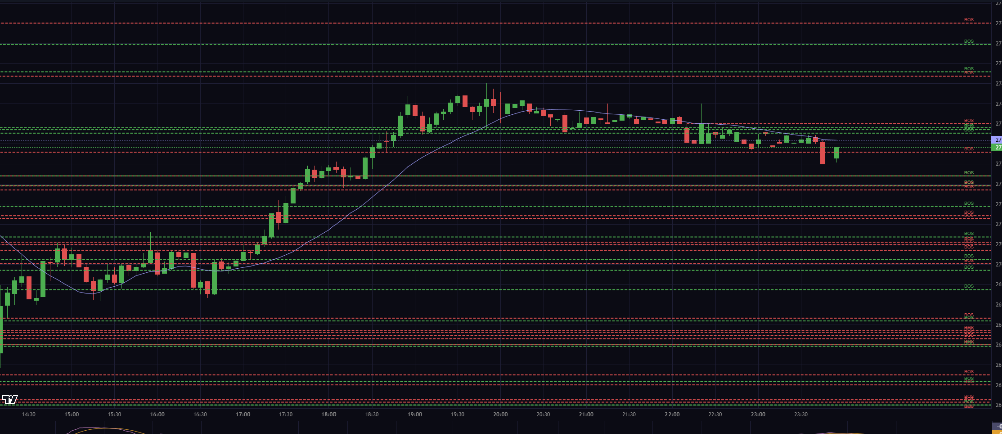

- The default setting is all the Structures off not On
- What is the meaning of Confluence?
- Explore the püossibility of flagging FVG existing on more that one time frame
- Use different colors for Bollinger bands (see screenshot bellow)
Green up Red dorn Blue midle
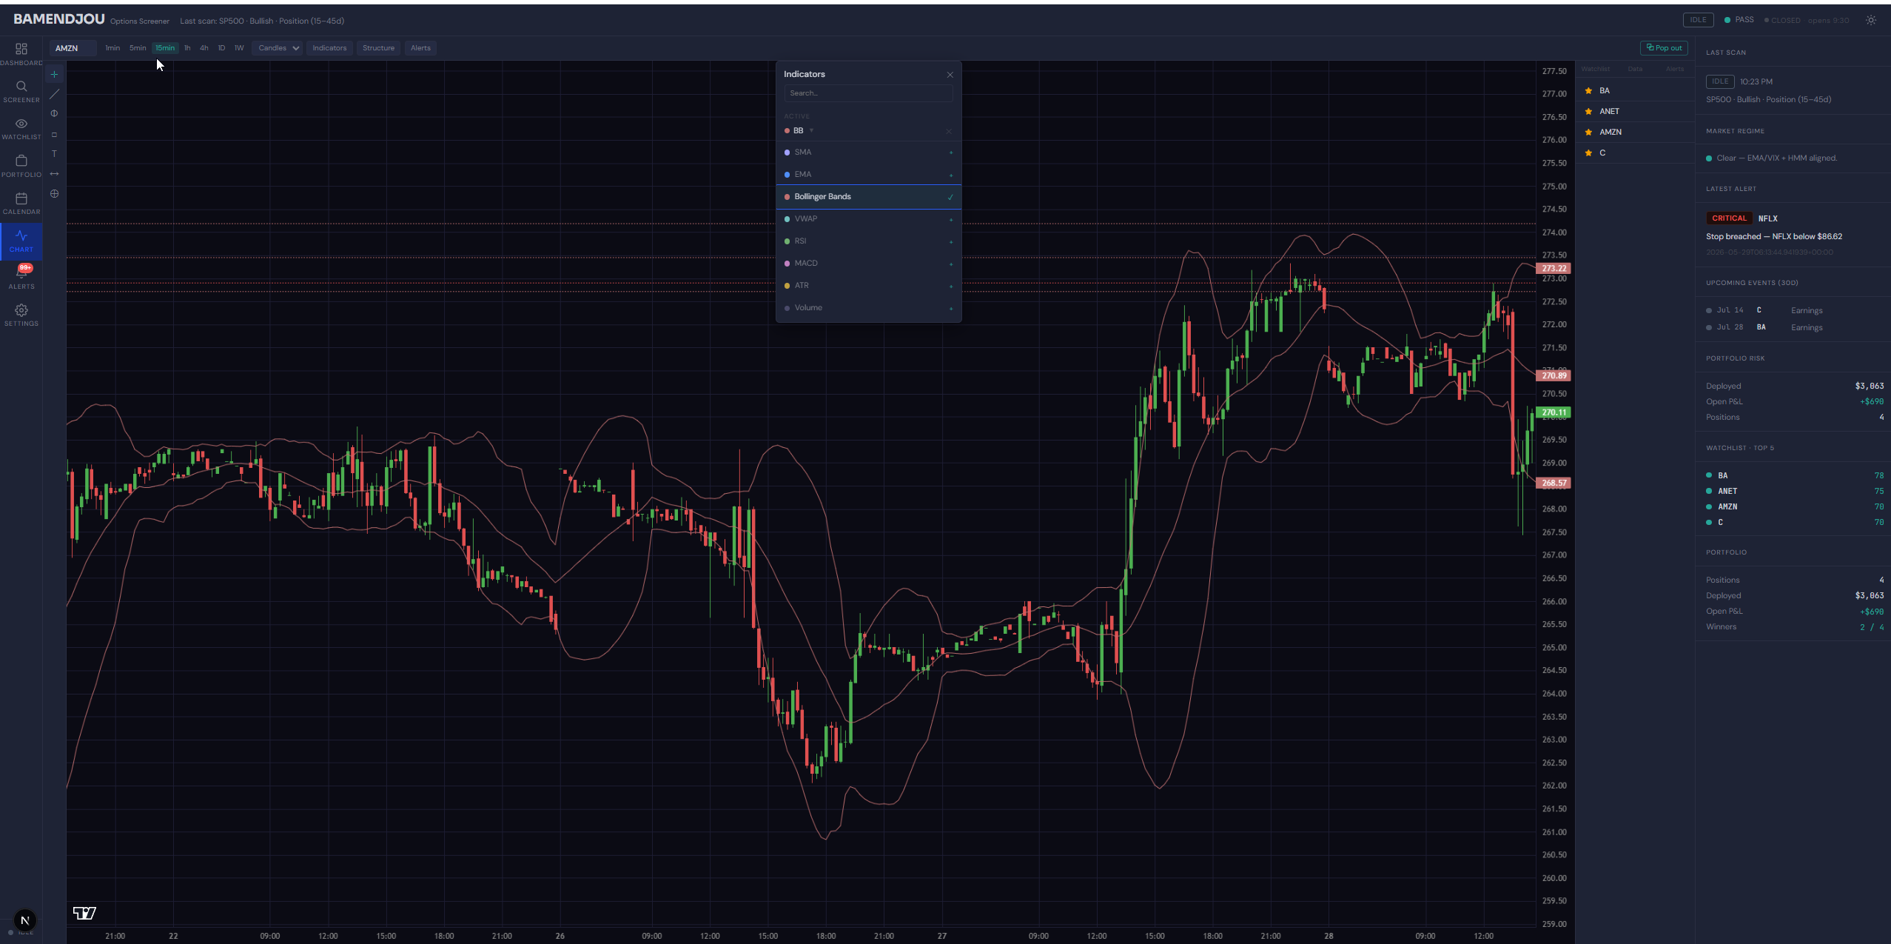
- 1 Hour 4 hours 1 Day and 1W time frame give No result
- When I select symbol in watchlist i want the Grap to be displayed (see screenshot bellow greenbox and arrow)
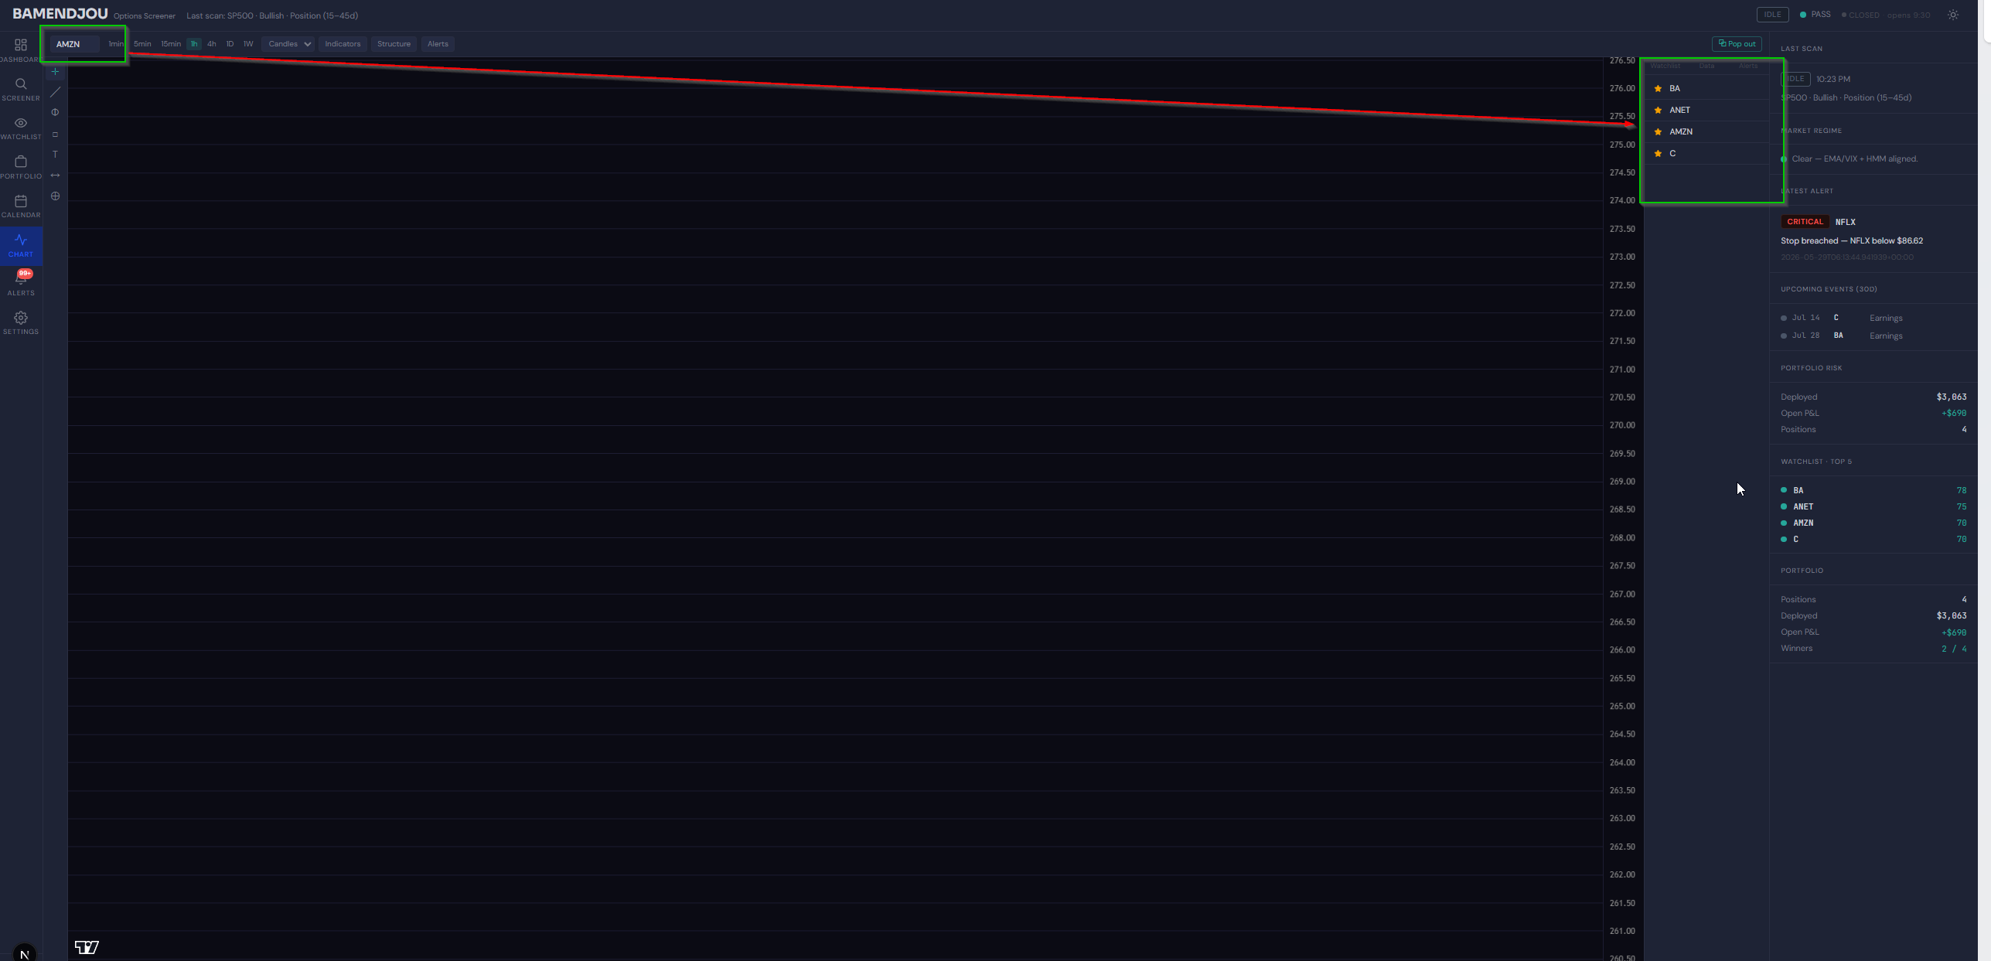

- Is this errorlog on CLX stock legit what does it mean ? can we get rid of it
  - 2026-05-29 07:22:16,146 INFO sqlalchemy.engine.Engine ROLLBACK
  - INFO: Application startup complete.
  - INFO: Uvicorn running on http://127.0.0.1:8000 (Press CTRL+C to quit)
  - INFO: 127.0.0.1:51776 - "WebSocket /chart/stream/CLX?interval=4h" [accepted]
  - INFO: connection open
  - $CLX: possibly delisted; no price data found (1h 2024-05-29 -> 2026-05-29) (Yahoo error = "1h data not available for startTime=1716955200 and endTime=1780027200. The requested range must be within the last 730 days.")
  - 1 Failed download:
  - ['CLX']: possibly delisted; no price data found (1h 2024-05-29 -> 2026-05-29) (Yahoo error = "1h data not available for startTime=1716955200 and endTime=1780027200. The requested range must be within the last 730 days.")
  - yfinance returned 0 bars for CLX [interval=4h]
  - No intraday data from any source for CLX

- Explore the possibility of calculating IVrank and percentile by ourselves. Do we have enough data? For which time frame
- Explore the possibility of creating sequential alerts. Alerts that fire if some conditions are sequentially mate. Condition donot happen simultaneously. Asses complexity performance reliability etc eg. Price enters FVG then Prise goes above 10 -> Fire alert
- In watchtlist Many sybols on the upper section of the grid do not match with the content of the table Core Delta next event seem to be broken. (see screenshot bellow)
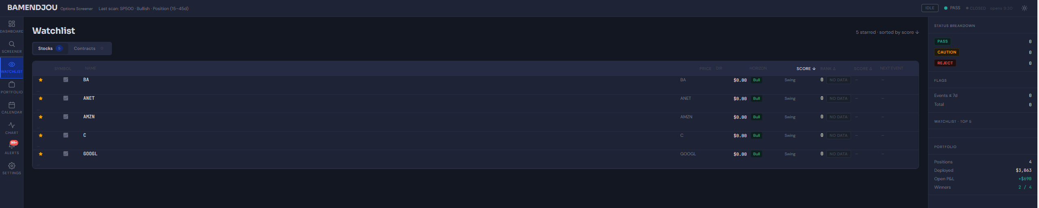
- Add a back button to the validation table that will bring us back to stock ranking(see screenshot bellow)
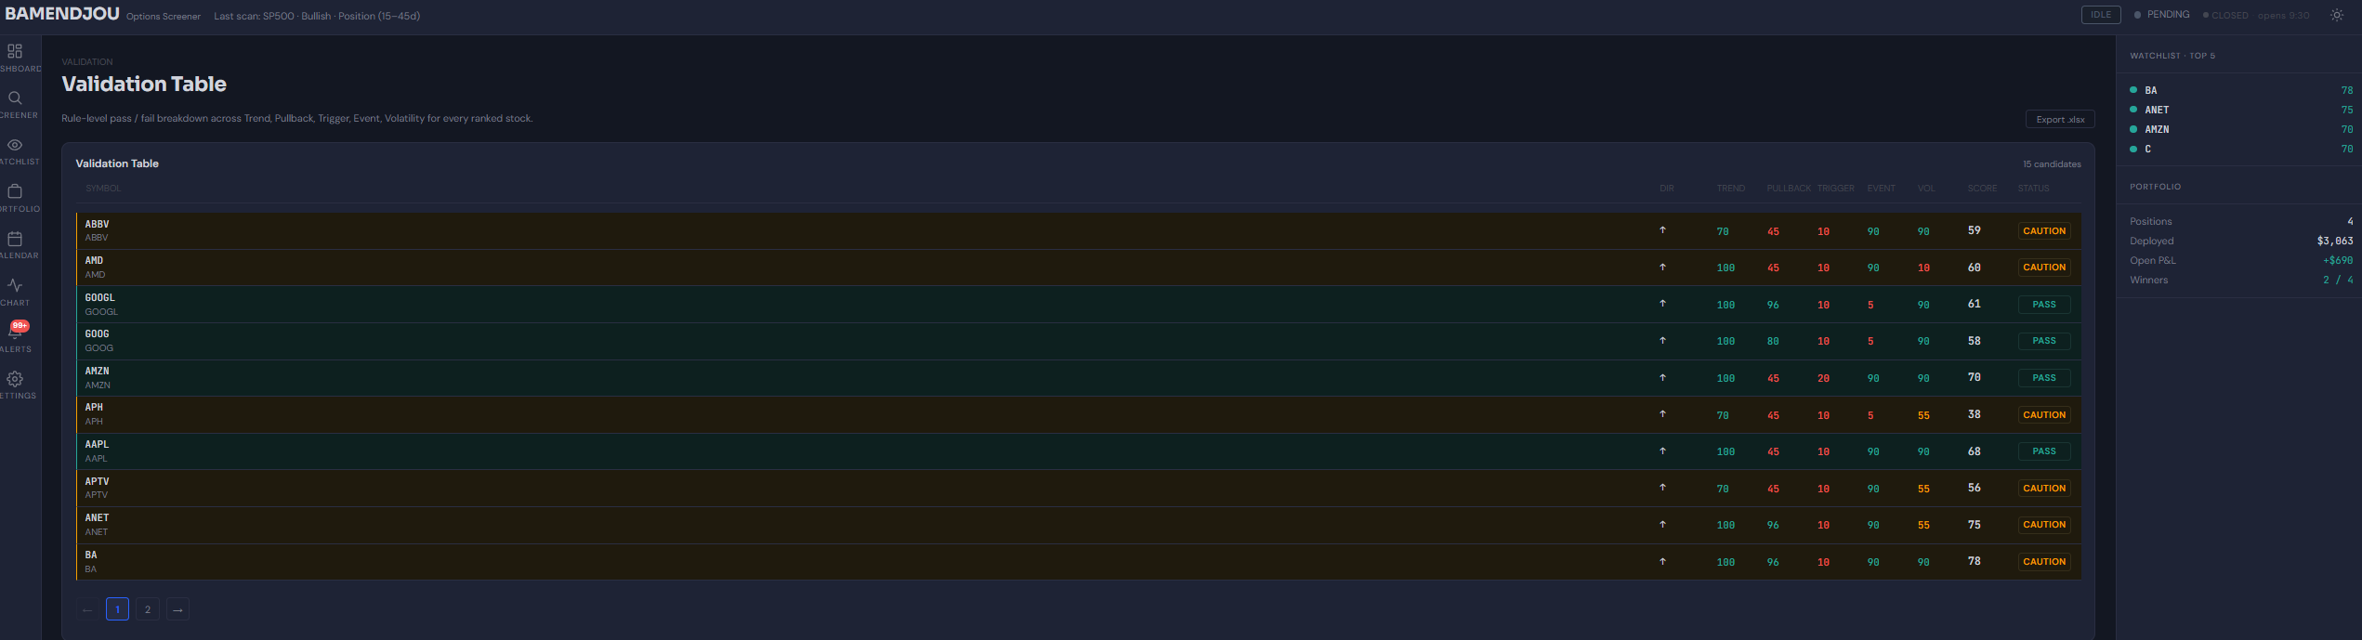
- Remove the (30D) beside Upcoming events since the events displayed cover a longer period(see screenshot bellow greenbox)
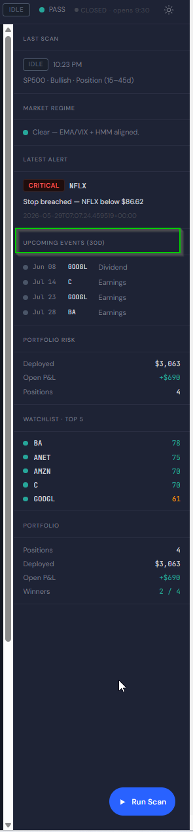
- Can we support multiple graph in 1 screen`? asses the implementation and complexity. I can for example look at different time frames

